**NAME: P.NITYASREE**

**REGNO: 17MIS1007**

**COURSE: INFORMATION SECURITY MANAGEMENT**

**COURSECODE: CSE3502**

**FACULTY: ANUSHA**

**DIGITAL ASSIGNMENT -1**

**VLAN CONFIGURATION FOR A INSTITUTION:**

**STEPS:**

1. **BUILD AND CONFIGURE THE TOPOLOGY USING SWITCH, ROUTER AND PC’S.**

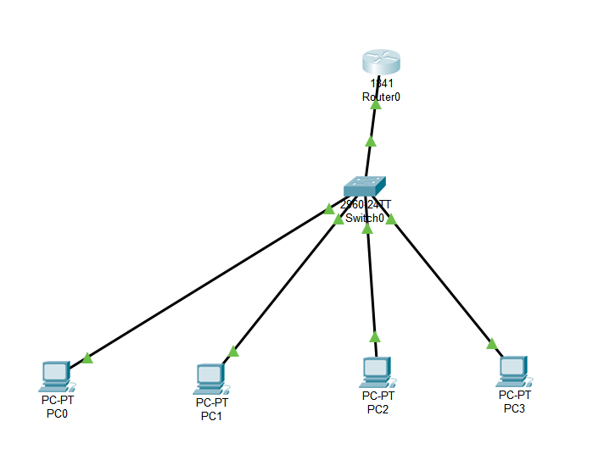

**ROUTER CONFIGURATION:**

1. **CONFIGURE THE ROUTER WITH IP ADDRESS AS 192.168.1.1 AND FASTETHERNET 0/O**

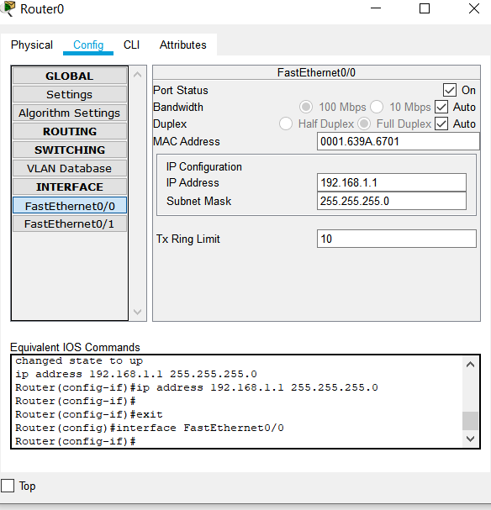

1. **PC0:**

**CONFIGURE THE PC0 WITH IP ADDRESS 192.168.1.2 AND FASTETHERNET 0/O AND DEFAULT GATEWAY AS 192.168.1.1**

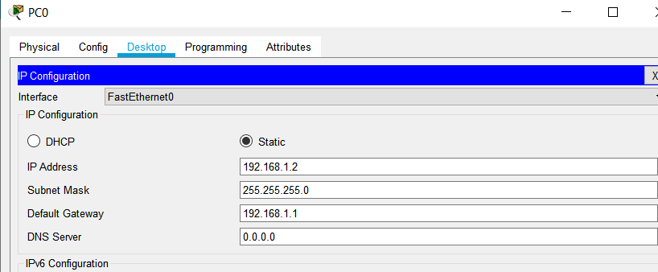

1. **PC1**

**CONFIGURE THE PC0 WITH IP ADDRESS 192.168.1.3 AND FASTETHERNET 0/O AND DEFAULT GATEWAY AS 192.168.1.1**

**:**

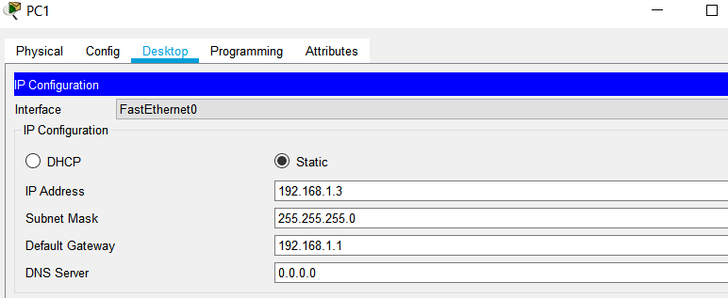

1. **SUCCESSFUL PACKET TRANSFER FROM PC0 TO ROUTER0 AND PC1 TO ROUTER0**

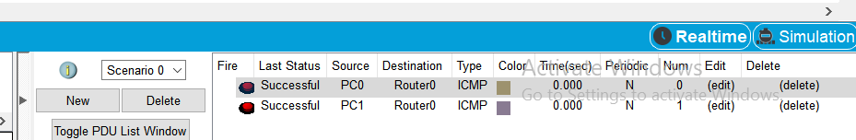

1. **CONFIGURE THE PC2 WITH IP ADDRESS 192.168.20..2 AND FASTETHERNET 0/O AND DEFAULT GATEWAY AS 192.168.1.1**

**PC2:**

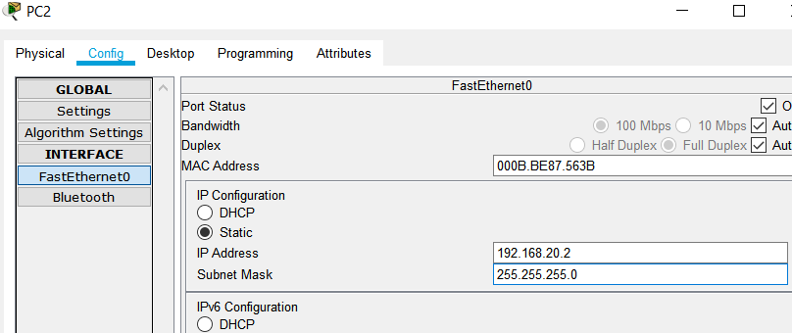

**PC3:**

1. **CONFIGURE THE PC3 WITH IP ADDRESS 192.168.20.3 AND FASTETHERNET 0/O AND SUBNET MASK AS DEFAULT 255.255.255.0**

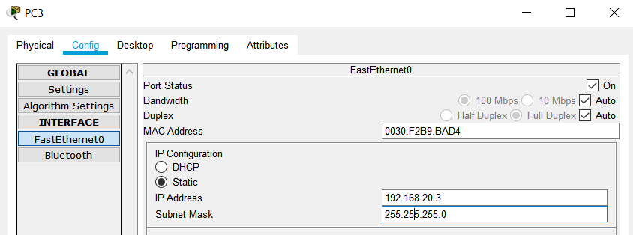

1. **THEN PHYSICAL VLAN CONFIGURATION AND CONFIGURATION OF ALL PC’S AND SWITCH**

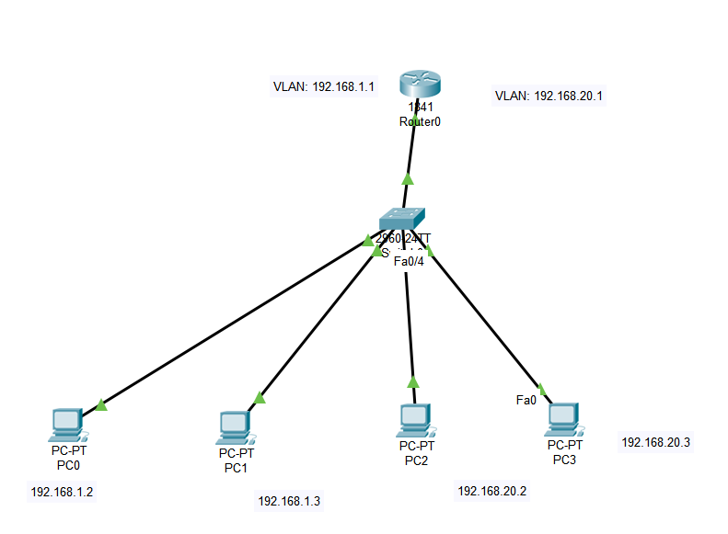

1. **CONFIGURATION OF SWITCH AS ENTER THE VLAN DATABASE AND ENTER THE VLAN NUMBER AND VLAN NAME**

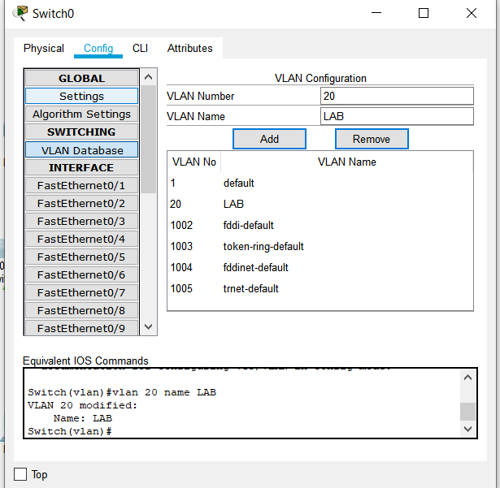

1. **ADDED VLAN DATABASE AND VLAN NUBER AS 20 AND VLAN NAME AS LAB**

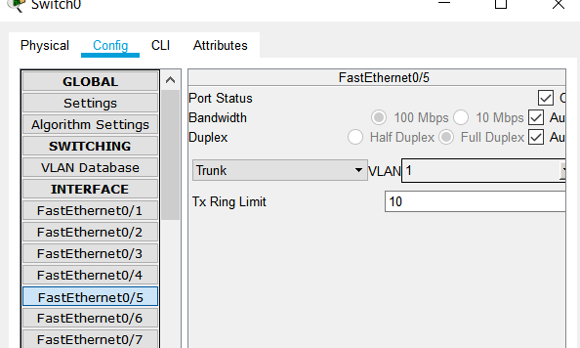

1. **CHECK FOR THE PORT AND CHANGE THE VLAN NUMBER AND ALSO CHANGE THE STATUS AS TRUNK.**
2. **CONFIGURE THE TERMINAL AND INTERFACE IT WITH THE FOLLOWING COMMANDS.**
3. **CONFIGURE WITH IP ADDRESS 192.168.20.1 AND FASTETHERNET 0/O**
4. **AND DEFAULT SUBNET MASK AS 255.255.255.0**

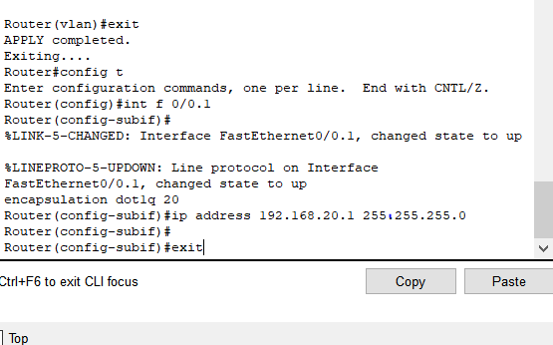

**15)**

**STATUS SUCCESSFUL FROM SOURCE TO DESTINATION AS FROM PC2 TO PC0**

**PC0 TO ROUTER0 , PC1 TO ROOTER 0**

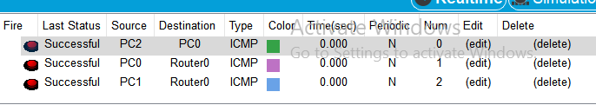

**END**